**DATA FLOW DAIGRAM – ONLINE SHOPPING SITE**

**LEVEL 0** – CONTEXT DAIGRAM FOR ONLINE SHOPPING SITE

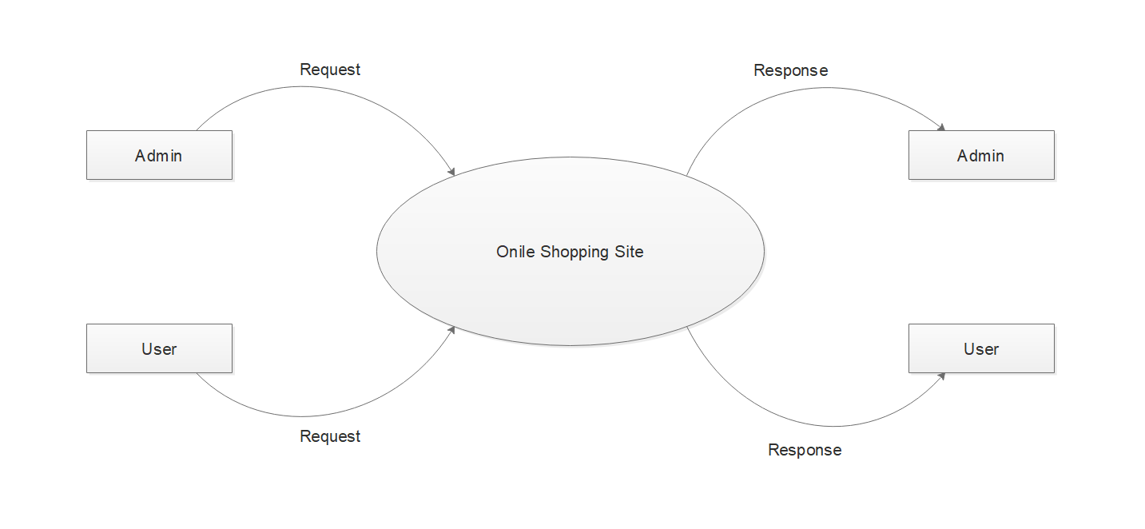

**LEVEL 1** – ADMIN DATA FLOW DAIGRAM FOR ONLINE SHOPPING SITE

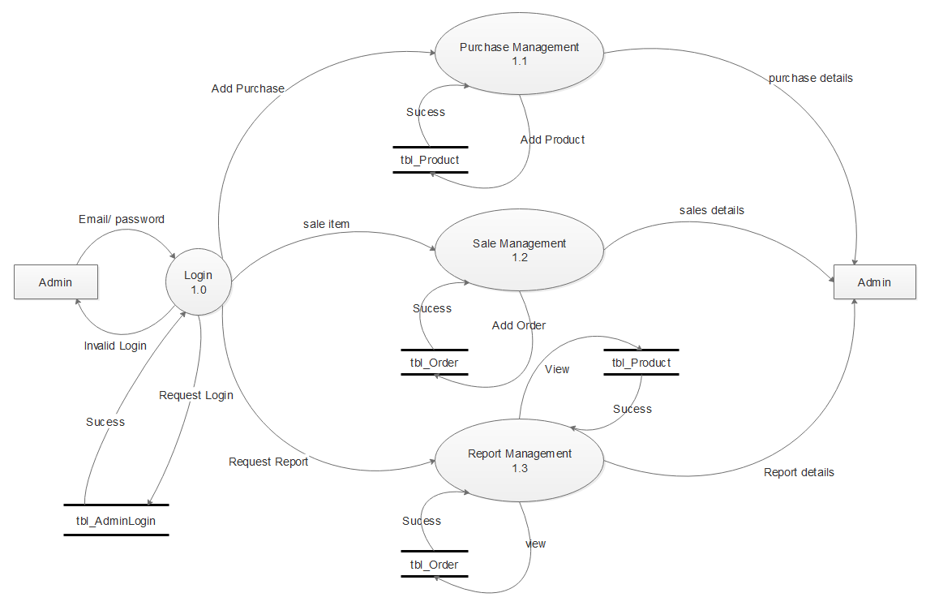

**LEVEL 1** – USER DATA FLOW DAIGRAM FOR ONLINE SHOPPING SITE

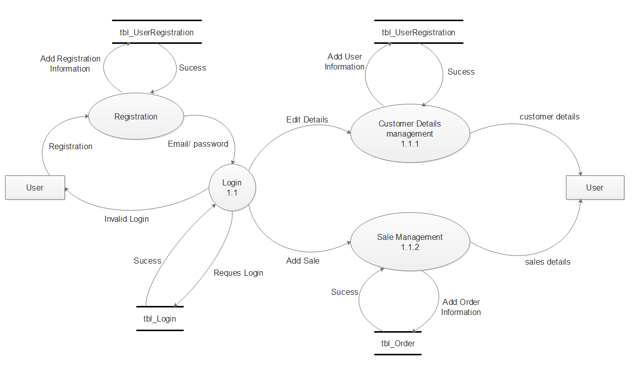

**LEVEL 2** – PURCHASE MANAGEMENT OF ADMIN

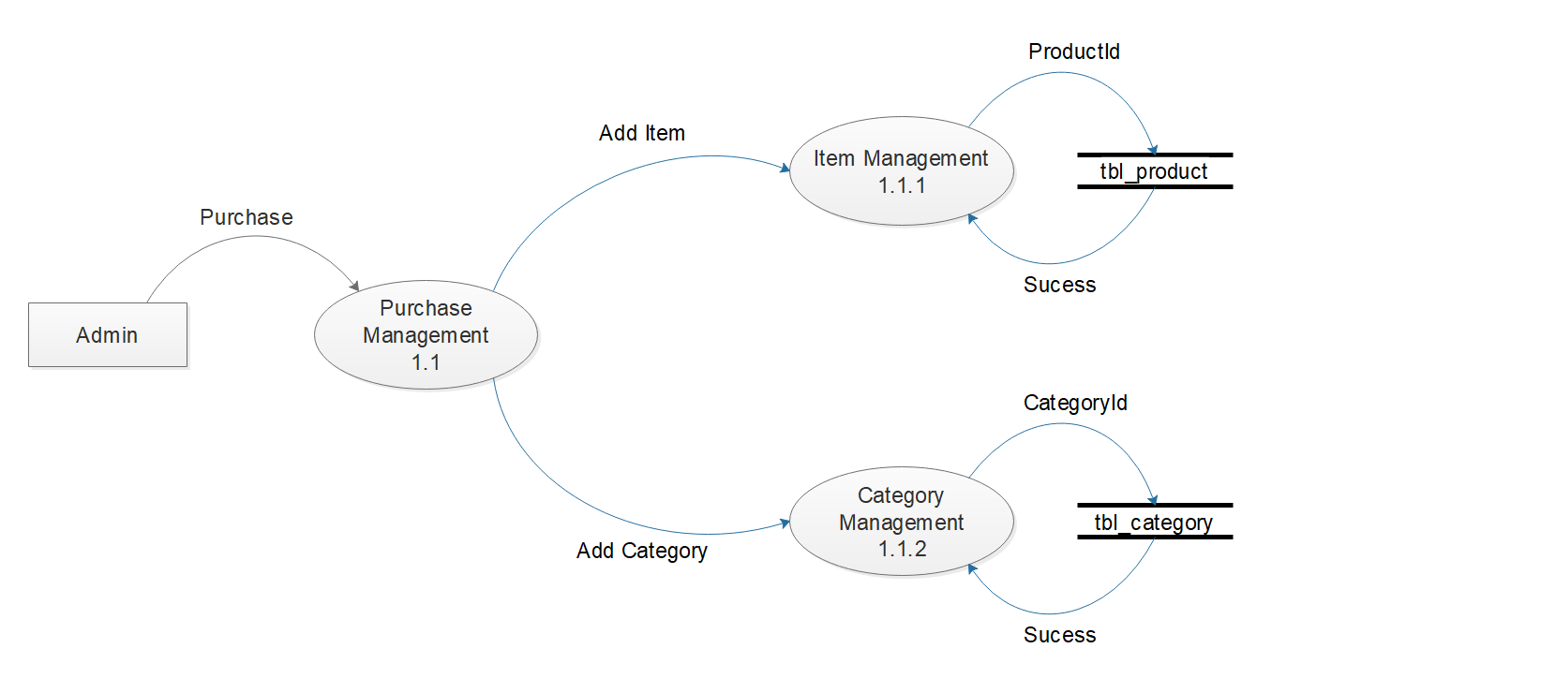

**LEVEL 2** – SALE MANAGEMENT OF ADMIN

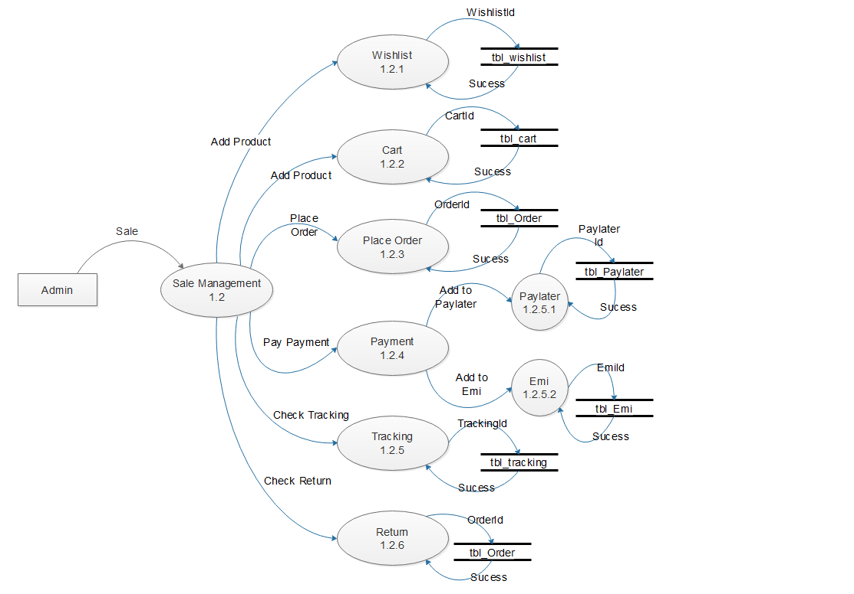

**LEVEL 2** – REPORT MANAGEMENT OF ADMIN

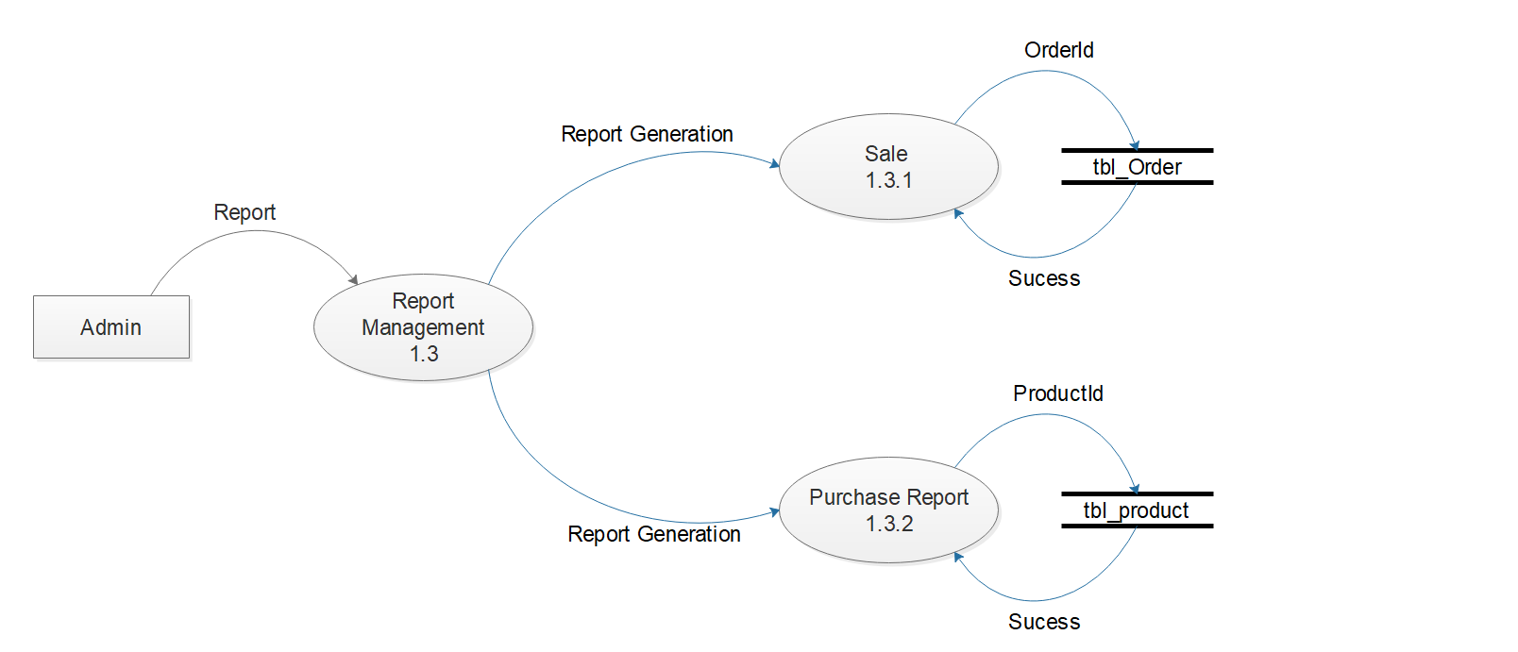

**LEVEL 2** – SALE MANAGEMENT OF USER

